**SESSION 2 HOMEWORK**

**Part A:** check the attached Python file.

**Part B:**

2. Boolean or Boolean algebra, in its basic meaning, is the rules for reasoning about and combining values of true or/and false. That is also the basis of computer logic.

3 different expression results a Boolean type:

1. 7 >= 8
2. 5 != 9
3. 3 <=6

3. Flow chart is a geometric method to perform the logical thinking and direction of solution.

***Flow chart:***

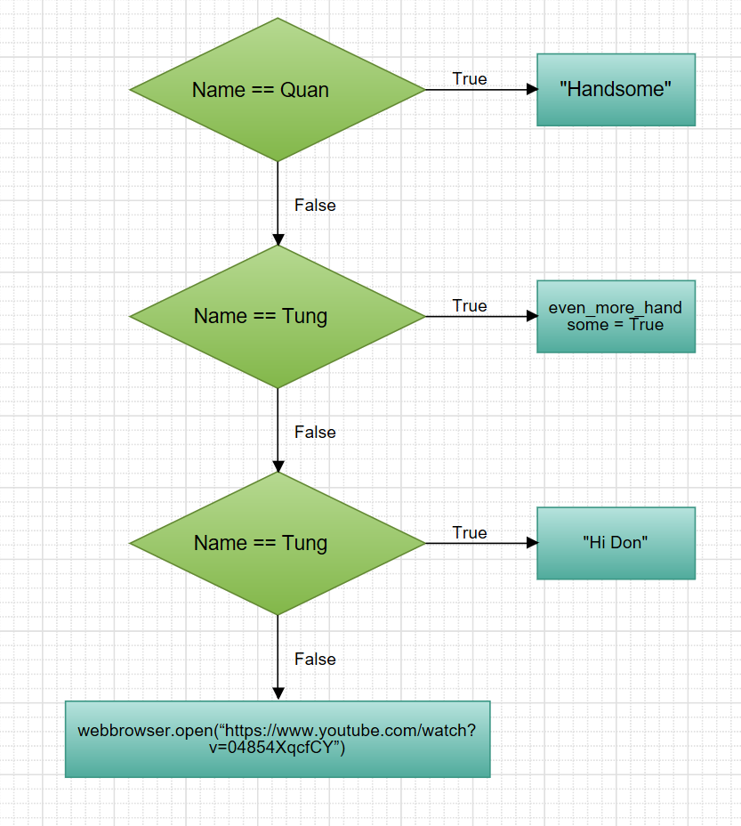

4. Nested conditionals mean a conditional containing another conditional, similar as outer and inner statement of conditional.

Example of nested conditionals:

n=int(input(“Choose a year: ”))

m=n//100

if n%4==0:

if m==0 and m%4!=0:

print(“Normal year”)

else:

print(“Leap year”)

else:

print(“Normal year”)

* Turtle Exercise: check the attached python file.

* Serious Exercise: Check the python file.